|  |  |
| --- | --- |
| **TEST URL** | **RESULT** |
| https://home-paypal-jp.moonkahonda.com/panel_JP/-/jp/xppl/ | Malicious |
| https://galsterberg.panomax.com/ | Legitimate |
| https://oberstdorf.panomax.com/schrattenwang | Legitimate |
| https://addons.mozilla.org/de/firefox/addon/mynthos-tv/?src=search | Legitimate |
| http://ord-amazsn.com | Malicious |
| http://ww17.login-appleid.apple.com.alert-wode.com/ | Malicious |
| http://support.facebook.com-uuynqiyacp.tekhencorp.com/ | Malicious |
| https://galsterberg.panomax.com/ | Legitimate |
| https://www.google.com/ | Legitimate |
| https://wallpapersite.com/abstract/ | Legitimate |
| https://www.freepik.com/free-vector | Legitimate |

Test Data

Test Results

1. Type a valid URL for example to fetch analysis:

<https://www.mi.com>

This is an example of Legitimate URL.

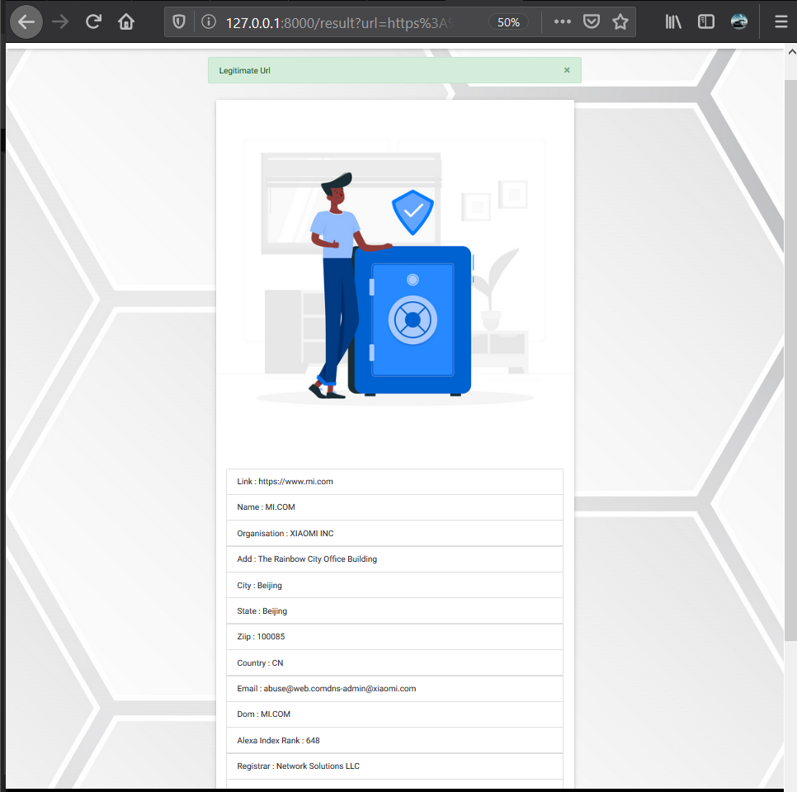

1. Another example of Legitimate URL

<https://technoutsav.techgig.com/>

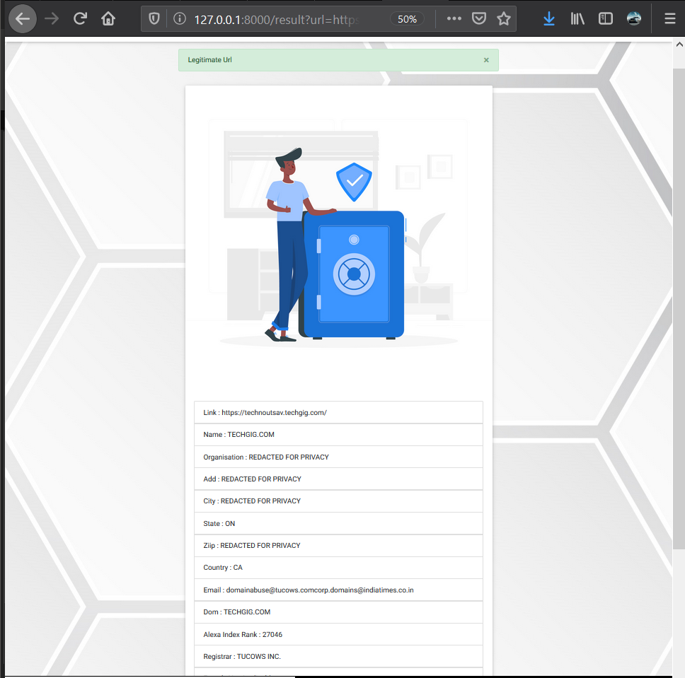

1. Another Legitimate URL

<https://www2.deloitte.com/in/en.html>

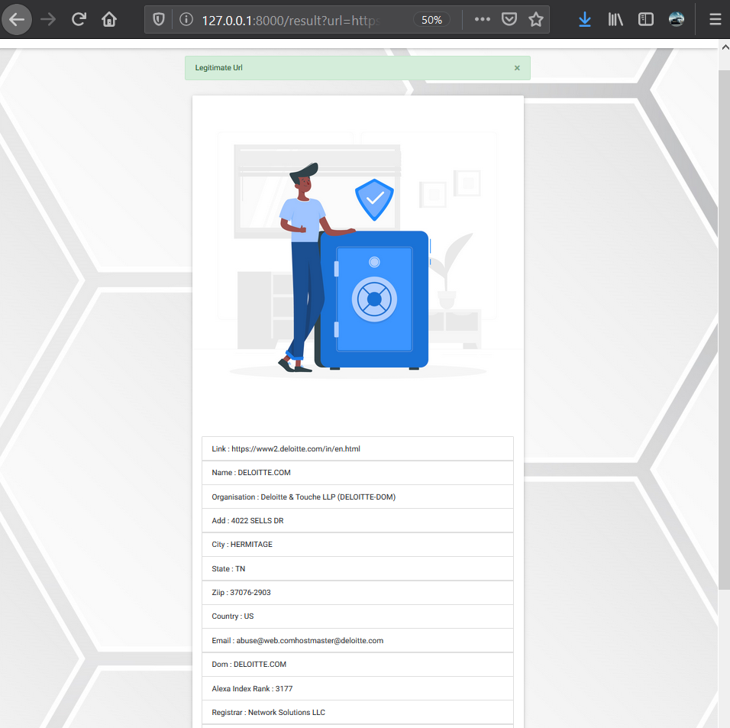

1. Example of Malicious Website

<http://www.dhilloncraneservice.com/.well-known/bankofamerica.com/>

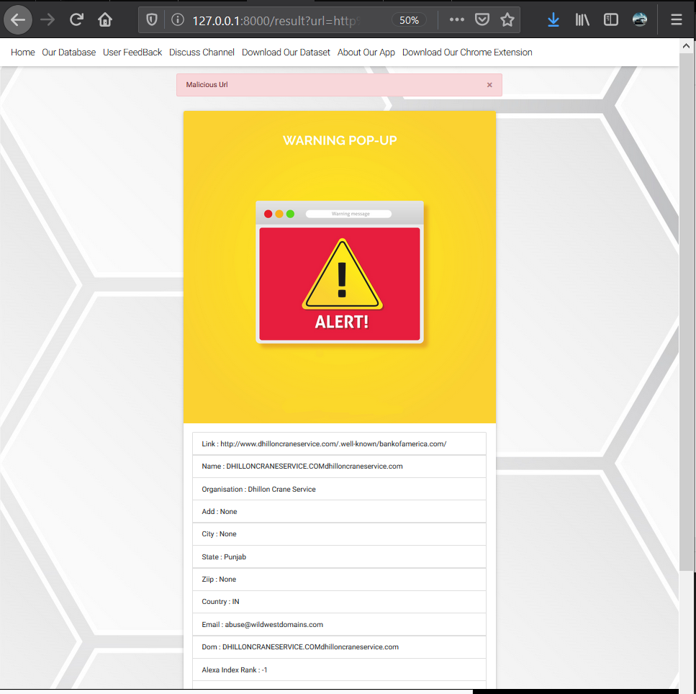

1. Another Malicious URL

<https://home-paypal-jp.moonkahonda.com/panel_JP/-/jp/xppl/>

